Website Navigation: History of Internet

**Aim**- The purpose of the document is to show how the website works.

**Working**-

**Home Page:**

1. At the top there is a navbar that includes to and fro navigation from “Home” to “History of Internet” or “About” or “Team” pages:



1. “History of Internet” page gives a brief about the Internet History. You can also go to this page using the Learn more button

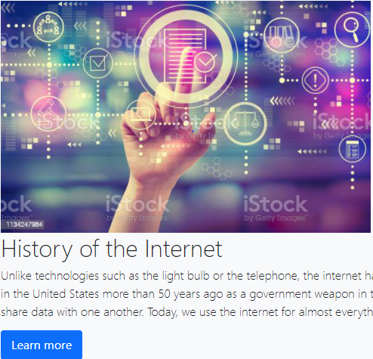

1. At the bottom, the Homepage contains links to 5 more pages that reflect the Internet evolution. These pages are:
   1. Internet Invention
   2. Browser Wars
   3. Web search Engines
   4. Dotcom Bubble”
   5. People Power pages, as show below:



**Internet Invention Page:**

* Includes Nav bar same, as present in the “Home” page.
* Contains information about “Internet Invention (Birth of Internet)” .
* Contains hyperlinks for the remaining four pages such as: “Browser Wars”, “Web search Engines”, “Dotcom Bubble” and “People Power” so that the user can easily navigate to the other pages from the same page instead of returning to home to access next information.
* **Browser Wars Page:**
* Includes Nav bar same as present in the “Home” page.
* Contains information about “Browser Wars (Netscape V/s Microsoft)”.
* Contains hyperlinks for the remaining four pages such as: “Internet Invention”, “Web search Engines”, “Dotcom Bubble” and “People Power” so that the user can easily navigate to the other pages from the same page instead of returning to home to access next information.

**Web search Engines Page:**

* Includes Nav bar same as present in the “Home” page.
* Contains information about “Web search Engines (Search engine development)”.
* Contains hyperlinks for the remaining four pages such as: “Internet Invention”, “Browser Wars”, “Dotcom Bubble” and “People Power” so that the user can easily navigate to the other pages from the same page instead of returning to home to access next information.

**Dotcom Bubble Page:**

* Includes Nav bar same as present in the “Home” page.
* Contains information about “Dotcom Bubble (Stock market)”.
* Contains hyperlinks for the remaining four pages such as: “Internet Invention”, “Browser Wars”, “Web search Engines” and “People Power” so that the user can easily navigate to the other pages from the same page instead of returning to home to access next information.

**People Power Page:**

* Includes Nav bar same as present in the “Home” page.
* Contains information about “People Power (Internet today)”.
* Contains hyperlinks for the remaining four pages such as: “Internet Invention”, “Browser Wars”, “Web search Engines” and “Dotcom Bubble” so that the user can easily navigate to the other pages from the same page instead of returning to home to access next information.

**About Page:**

* Includes Nav bar same as in the “Home” page.
* Contains the information regarding the project assignment details such as the course name, Professor and the tools used while making the website
* Contains reference material links used while working on the content of the website

**Team Page:**

* Includes Nav bar same as present in the “Home” page.
* Contains the brief information about the project team members and hyperlinks to their LinkedIn profiles.